AI Assignment 01
ASSINGMENT NO. | 8
TITLE | Artificial Intelligence & Robotics
PROBLEM STATEMENT /DEFINITION | Solve following 6-tiles problem stepwise using A* algorithm,  Initial Configuration:  Final Configuration:  Constraint: Tiles can be shifted left or right 1 or 2 positions with cost 1 and 2  respectively.
  B | W | B | W | B | W
  B | B | B | W | W | W
OBJECTIVE | To learn and implement A* algorithm
OUTCOME | Students will be able to implement A* algorithm for 6-tiles problem
S/W PACKAGES AND  HARDWARE APPARATUS USED | Operating System recommended :- 64-bit Open source Linux or its derivative Programming Languages: Prolouge-python
REFERENCES | 1. Deepak Khemani, “A First Course in Artificial Intelligence”, McGraw Hill Education(India), 2013, ISBN : 978-1-25-902998-1  2. Elaine Rich, Kevin Knight and Nair, “Artificial Intelligence”, TMH, ISBN-978-0-07- 008770-5 3
INSTRUCTIONS FOR  WRITING JOURNAL | 1. Date  2. Assignment no.  3. Problem definition  4. Learning objective  5. Learning Outcome  6. Concepts related Theory  7. Algorithm  8. Test cases  9. Conclusion/Analysis

A*SearchAlgorithm:
A* Search algorithm is one of the best and popular technique used in path-finding and graph traversals.
Explanation:
Consider a square grid having many obstacles and we are given a starting cell and a target cell. We want to reach the target cell (if possible) from the starting cell as quickly as possible. Here A* Search Algorithm comes to the rescue.
What A* Search Algorithm does is that at each step it picks the node according to a value-‘f’ which is a parameter equal to the sum of two other parameters – ‘g’ and ‘h’. At each step it picks the node/cell having the lowest ‘f’, and process that node/cell.
We define ‘g’ and ‘h’ as simply as possible below:
g = the movement cost to move from the starting point to a given square on the grid, following the path generated to get there.
h = the estimated movement cost to move from that given square on the grid to the final destination. This is often referred to as the heuristic, which is nothing but a kind of smart guess. We really don’t know the actual distance until we find the path, because all sorts of things can be in the way (walls,

water, etc.). There can be many ways to calculate this ‘h’ which are discussed in the later sections.
It is best-known form of Best First search. It avoids expanding paths that are already expensive, but expands most promising paths first.
f(n) = g(n) + h(n), where
- g(n) the cost (so far) to reach the node
- h(n) estimated cost to get from the node to the goal
- f(n) estimated total cost of path through n to goal. It is implemented using priority queue by increasing f(n).
Algorithm:
We create two lists – Open List and Closed List (just like Dijkstra Algorithm)
// A* Search Algorithm
1. Initialize the open list
2. Initialize the closed list
put the starting node on the open
list (you can leave its f at zero)

3. while the open list is not empty
a) find the node with the least f on
the open list, call it "q"

b) pop q off the open list

c) generate q's 8 successors and set their
parents to q

d) for each successor
i) if successor is the goal, stop search
successor.g = q.g + distance between
successor and q
successor.h = distance from goal to
successor (This can be done using many
ways, we will discuss three heuristics-
Manhattan, Diagonal and Euclidean
Heuristics)

successor.f = successor.g + successor.h

ii) if a node with the same position as
successor is in the OPEN list which has a
lower f than successor, skip this successor

iii) if a node with the same position as
successor is in the CLOSED list which has
a lower f than successor, skip this successor
otherwise, add the node to the open list
end (for loop)

e) push q on the closed list
end (while loop)
So suppose as in the below figure if we want to reach the target cell from the source cell, then the A* Search algorithm would follow path as shown below. Note that the below figure is made by considering Euclidean Distance as a heuristics.
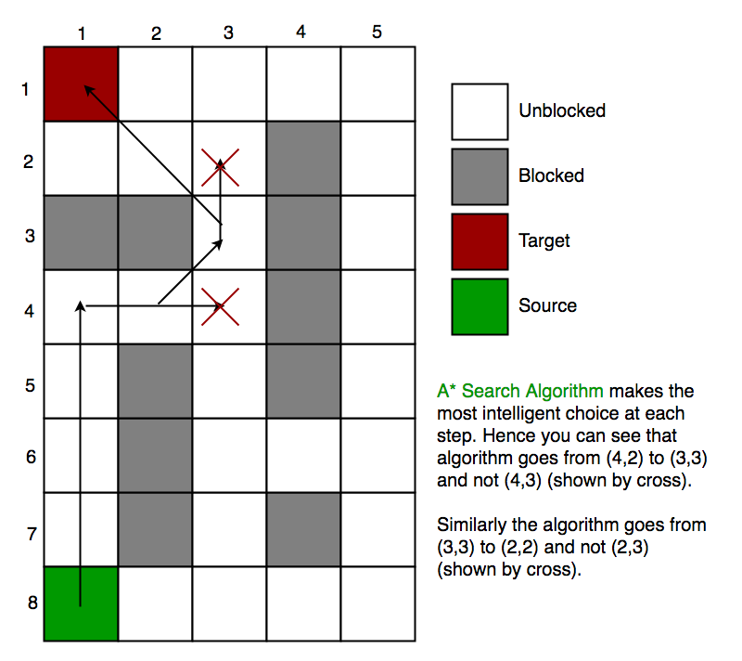
Advantages:
1.It is the best one from other techniques.
2.It is used to solve very complex problems.
3.It is optimally efficient, i.e. there is no other optimal algorithm guaranteed to expand fewer nodes than A*.
4.It is complete and optimal.
Disadvantages:
1.This algorithm is complete if the branching factor is finite and every action has fixed cost.
2.The speed execution of A* search is highly dependant on the accuracy of the heuristic algorithm that is used to compute h (n).
3.It has complexity problems.

Review Questions:
1. What is the other name of informed search strategy?
2. How many types of informed search method are in artificial intelligence?
3.Which search uses the problem specific knowledge beyond the definition of the problem?
4. Which function will select the lowest expansion node at first for evaluation?
5.Which search is complete and optimal when h(n) is consistent?
6.Which is used to improve the performance of heuristic search?
7.Which search method will expand the node that is closest to the goal?

8.Is A∗’s search behavior necessarily “exponentially explosive”?
9.If h() is admissible and s is the start node, how is h(s) related to the cost of the solution found by A∗search?
10.What happens if we use a heuristic h() in A∗ search that does not have the guarantee that
h(n)≤h∗(n) for all states n.

